**Assignment 2:**

**Task 3. Aggregate functions, Having, Order By, GroupBy and Joins:**

1. **Write an SQL query to retrieve a list of all orders along with customer information (e.g., customer name) for each order.**

* The sql query to retrieve a list of all orders along with customer information is you can use joins where the data related to the orders table and customers table the query looks like :
* **SELECT o.OrderID, c.FirstName, c.LastName, c.Email, o.OrderDate FROM orders o JOIN customers c ON o.CustomerID = c.CustomerID;**

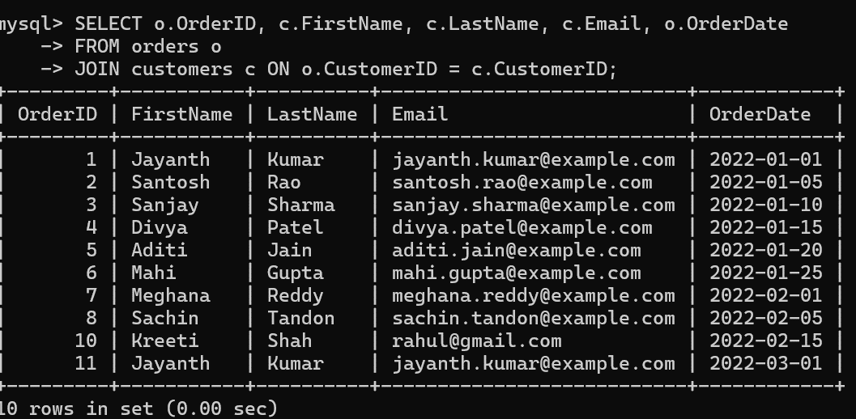

1. **Write an SQL query to find the total revenue generated by each electronic gadget product. Include the product name and the total revenue.**

* The sql query to find the total revenue generated by each electronic gadget product is can be done by using the sum aggregate function to get the total sum the query looks like:

**SELECT p.ProductName, SUM(od.Quantity * p.Price) AS TotalRevenue**

**FROM orderdetails od**

**JOIN products p ON od.ProductID = p.ProductID**

**WHERE p.Description LIKE '%electronic gadget%'**

**GROUP BY p.ProductName;** but u cant the get data because there is no such description with electronic gadget so nothing will be shown .

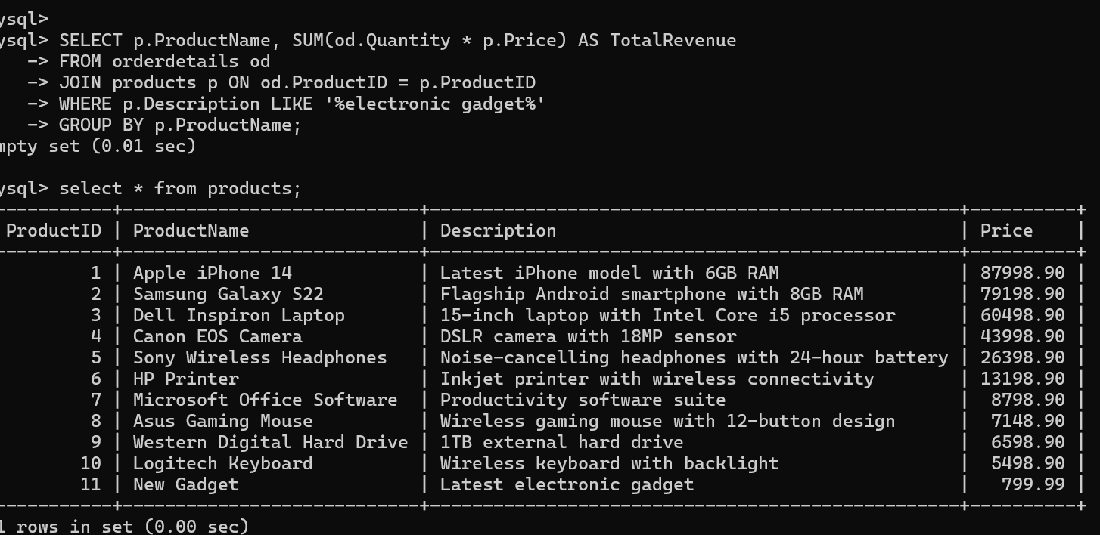

**3. Write an SQL query to list all customers who have made at least one purchase. Include their**

**names and contact information.**

* The sql query to list all the customers who have made at least one purchase including their names and contact information is you can do the by using the joins

**SELECT c.FirstName, c.LastName, c.Email, c.Phone**

**FROM customers c**

**JOIN orders o ON c.CustomerID = o.CustomerID**

**GROUP BY c.CustomerID;**

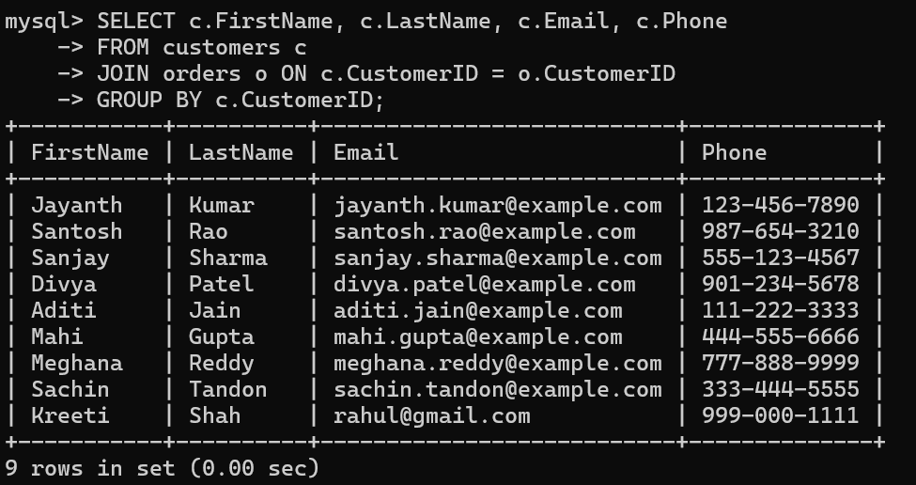

**4.Write an SQL query to find the most popular electronic gadget, which is the one with the highest total quantity ordered. Include the product name and the total quantity ordered.**

* The sql query to find the most popular electronic gadget which is the one with the highest total quantity ordered the query looks like :

**SELECT p.ProductName, SUM(od.Quantity) AS TotalQuantity**

**FROM orderdetails od**

**JOIN products p ON od.ProductID = p.ProductID**

**WHERE p.Description LIKE '%electronic gadget%'**

**GROUP BY p.ProductName**

**ORDER BY TotalQuantity DESC**

**LIMIT 1;**

There is no attribute like% electronic gadget so that you cant get the information about it .

**5. Write an SQL query to retrieve a list of electronic gadgets along with their corresponding categories.**

* The sql query for the list of electronic gadgets cant be done cause you cant have the data with no attributes in such a way that its difficult to get the data but if u want u can generate it using the joins the query looks like this :

**SELECT p.ProductName, p.Description**

**FROM products p**

**WHERE p.Description LIKE '%electronic gadget%';**

**6. Write an SQL query to calculate the average order value for each customer. Include the customer's name and their average order value.**

* The sql query to calculate the average order value for each customer including the customer's name and their average order value is by using the joins

**SELECT c.FirstName, c.LastName, AVG(o.TotalAmount) AS AverageOrderValue**

**FROM customers c**

**JOIN orders o ON c.CustomerID = o.CustomerID**

**GROUP BY c.CustomerID;**

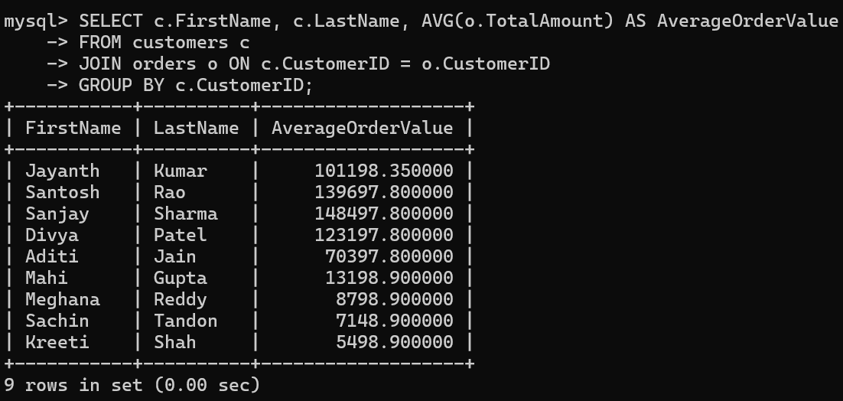

**7. Write an SQL query to find the order with the highest total revenue. Include the order ID, customer information, and the total revenue.**

* The sql query to find the order with the highest total revenue include the orderid customer informationand total revenue

**SELECT o.OrderID, c.FirstName, c.LastName, SUM(od.Quantity * p.Price) AS TotalRevenue**

**FROM orders o**

**JOIN customers c ON o.CustomerID = c.CustomerID**

**JOIN orderdetails od ON o.OrderID = od.OrderID**

**JOIN products p ON od.ProductID = p.ProductID**

**GROUP BY o.OrderID**

**ORDER BY TotalRevenue DESC**

**LIMIT 1;**

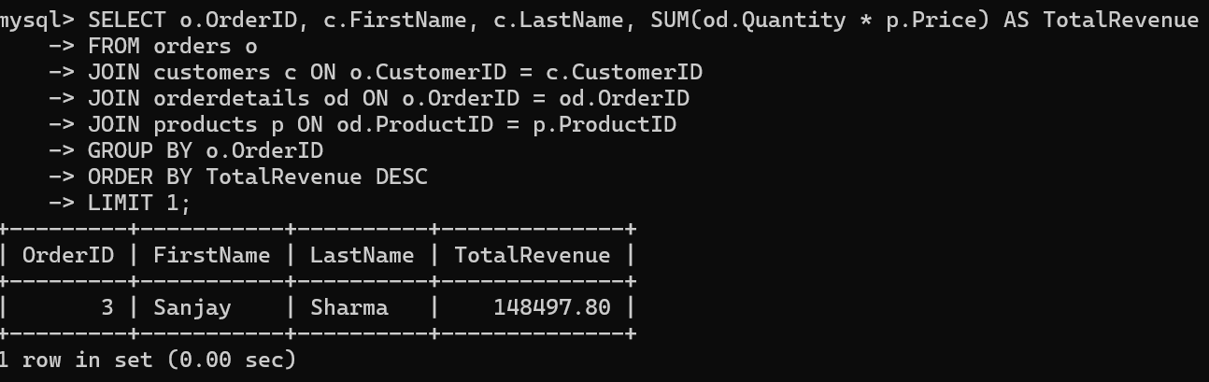

**8. Write an SQL query to list electronic gadgets and the number of times each product has been ordered.**

* The sql query to list electronic gadgetsand the number of times each product has been ordered is can be find out using the joins between the ordersdetails table and products table .

**SELECT p.ProductName, COUNT(od.OrderDetailID) AS OrderFrequency**

**FROM products p**

**JOIN orderdetails od ON p.ProductID = od.ProductID**

**GROUP BY p.ProductName;**

**9. Write an SQL query to find customers who have purchased a specific electronic gadget product. Allow users to input the product name as a parameter.**

* The SQL query to find the specific orders pirchsed by the users done by set product name and select query

**SELECT c.FirstName, c.LastName, c.Email FROM customers cJOIN orders o ON c.CustomerID = o.CustomerID JOIN orderdetails od ON o.OrderID = od.OrderID JOIN products p ON od.ProductID = p.ProductID WHERE p.ProductName = 'Apple iPhone 14';**

**10. Write an SQL query to calculate the total revenue generated by all orders placed within a specific time period. Allow users to input the start and end dates as parameters**

* We can get the sql query for the relevant orders purchses using the like and between in such a way that start and end date should be give to the console the sql query looks like :

**SELECT SUM(od.Quantity * p.Price) AS TotalRevenue**

**FROM orders o**

**JOIN orderdetails od ON o.OrderID = od.OrderID**

**JOIN products p ON od.ProductID = p.ProductID**

**WHERE o.OrderDate BETWEEN 2022-01-01 AND 2022-02-15;**

